Summer 2013 Mr. McGowan
AP Calculus AB Minuteman Tech
Quiz 16 – Partial Fractions + Trig Substitutions

1) 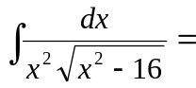 2) 